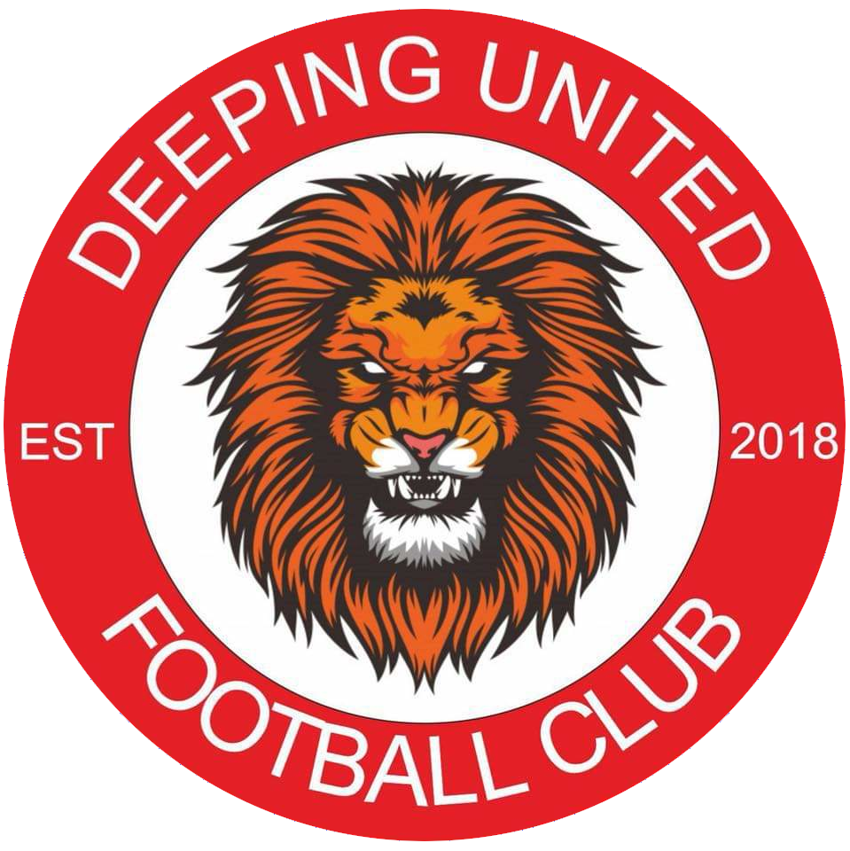

Prospectus

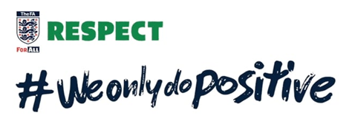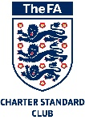
First of all, may we express our thanks for your interest in our club and we hope you will take the time to review our prospectus.
As a not for profit organisation, we at Deeping United FC are always very keen to make contact with organisations who are keen provide us with support and in return share in the success of the club and also take advantage of the promotional outcomes the club can offer.

In this prospectus the club will articulate its mission, core vision and values, some background of the club and also the options available for us to work in partnership moving forward.
We are keen to stress we see this very much as a partnership and are clearly very keen that you, as a potential partner, reap the rewards of a relationship with our club.
We will articulate the packages available, but clearly, we are always open to discussing bespoke packages which will maximise value to the club and your organisation.

In addition to our presence at our training ground in the Deepings our website and social media presence also offers an opportunity to promote our relationship:
This Photo by Unknown Author is licensed under CC BY-NC
https://www.deepingunitedfc.com

https://en-gb.facebook.com/pages/category/Professional-Sports-Team/Deeping-United-FC-1986982461620859/
This Photo by Unknown Author is licensed under CC BY-SA
https://twitter.com/deepingunited18
This Photo by Unknown Author is licensed under CC BY-SA
This Photo by Unknown Author is licensed under CC BY-SA
https://www.instagram.com/p/CCRksVcJoSk/?igshid=1w6443f8x3w6v

Should you require any further information about our club or wish to discuss further opportunities for us to work in partnership then please contact us as commercial@deepingunitedfc.com
Our Mission, Vision and Values
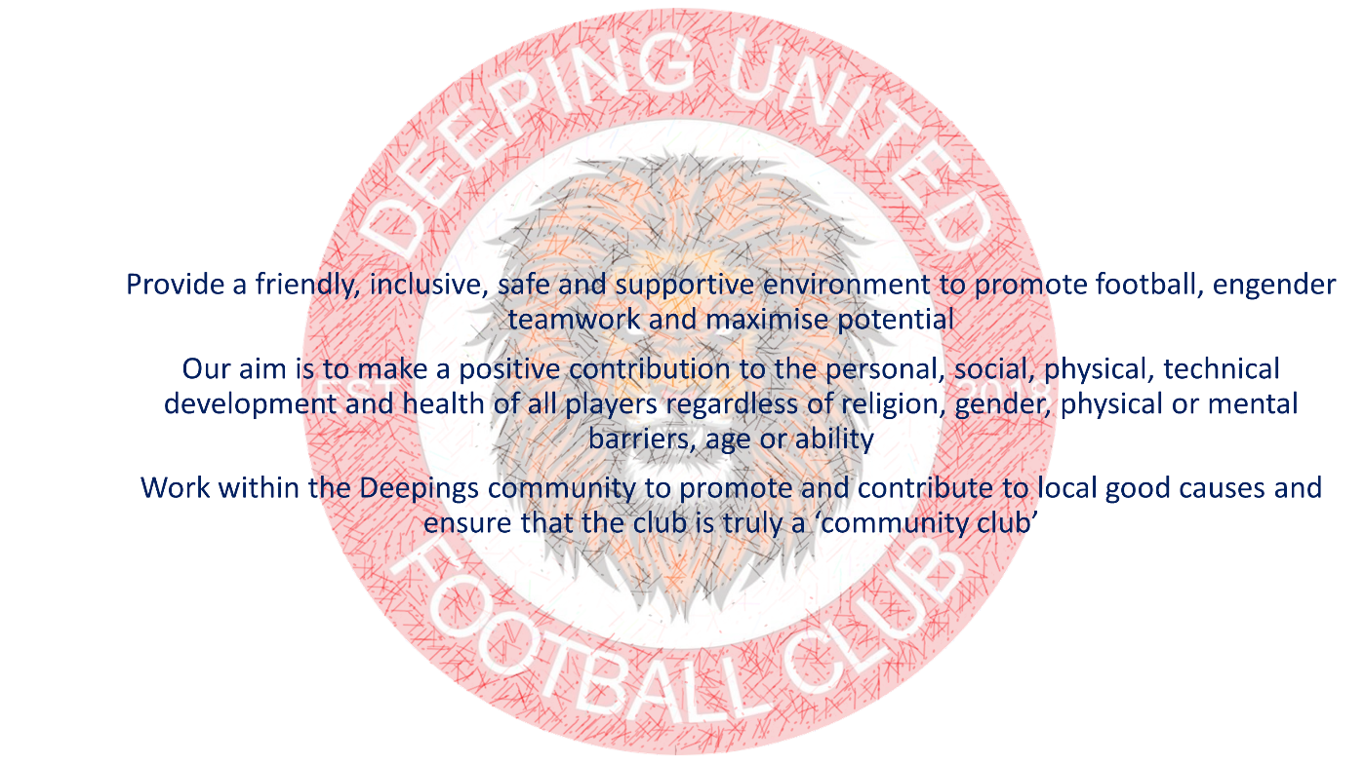
Vision
- Deeping United Football Club is an FA Charter Standard Football Club – We strive to remain at the pinnacle of the FA development pyramid
- Provide a fully inclusive environment ensuring opportunities to all regardless of ability
- Provide a friendly and safe environment to players of all ages
- Enable our players and coaches to develop and grow and gain new skills and qualifications
- Make the club part of the community and promote and contribute to local good causes
- Help the youth players to develop and grow and take this into their everyday lives

Values
- Everyone in the club players, coaches and all volunteers are respectful, disciplined and responsible
- Encourage sportsmanship and fair play

Our Club
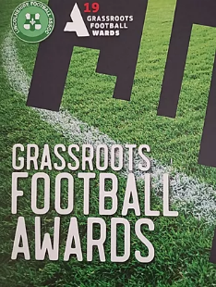
Deeping United Football Club was established in 2018 with 3 squads with a view to offer children of either gender, of all ages and abilities the chance to get active and learn the art of football. We have quickly built a reputation and grown our football community offering to 20 teams in one full season. At the end of the 2018-19 season the club were awarded Lincolnshire FA Grassroots Project of the Year award and gained FA Charter Standard status.

Our ethos in the community as an inclusive club offering a footballing pathway for both male and females from Under 5 years to Over 55s under one community club umbrella. We work alongside the local Parish Councils and Deeping Lions to maximise the ‘community feel’ of the club.
​
During 2018 we have formed a professional, strong, passionate and ambitious committee, driven to push the club forward! We started with 4 qualified coaches to offer top quality coaching for the players. All volunteers offering their time and knowledge to offer the very best to all within the club.
​
With the backroom positions filled and everything behind the scenes sorted we opened our doors for the first time.
To our amazement we were greeted by 70+ youngsters wanting to join our adventure..... as the weeks unfolded that 70 turned into over 120 youngsters.
We were completely overwhelmed by the vast numbers wanting to be a part of the Deeping United F.C. adventure..... but as a committee we set out to get extra coaches on board to be able to offer ALL the chance to join us. As a club we decided we would do something other clubs don’t offer, we paid to put people through their coaching badges so we had enough coaches and we didn’t have to turn any of the children away.
We now currently have boys and girls youth teams ranging in ages from under five through to under eighteen and five mens and ladies adult teams. We are also looking to create new disability and walking football teams.

As described in our mission statement we are very keen as a club to ensure that provide a friendly, inclusive, safe and supportive environment for players to flourish. To that end Deeping United FC boasts a large number of coaches all trained to FA Level One, with some trained to FA level two.
In addition to our coaches we also have a number of fully trained Welfare and Safeguarding Officers. Deeping United FC takes the welfare of players and coaches very seriously hence why we have a larger than normal ratio of officers to players/coaches (https://www.deepingunitedfc.com/welfare-and-safeguarding).

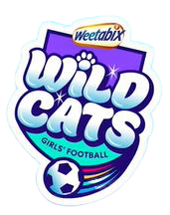
In 2020, Deeping United FC was also designated as a Wildcats centre by the Football Association which provides enhanced support for girls football at the club. This is a significant step forward in the ambitions of the club to promote football irrespective of gender, as highlighted in our mission statement and places us firmly on the map given we are the only Wildcats centre in south Lincolnshire.

Deeping United FC in the community
As described in our mission statement, Deeping United FC is committed to cementing our place as a community club.
Although we are a ‘not for profit’ club, we have never lost sight of our desire to provide a positive impact to individuals and groups in the community whether that be fund raising or simply helping out when we can.

Garth School
Garth School is a special needs school in the heart of Spalding with pupils aged between 2 and 19 years old
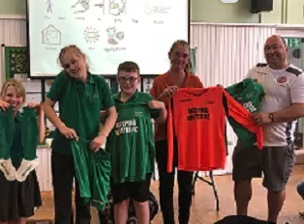
​At a recent football tournament, attended by representatives from Deeping United, we found that the school had no football kit for the children to use. As a result, the club decided to help the school and pictured are club representatives Lee and Emma presenting the new football kit to delighted pupils.

Age Concern
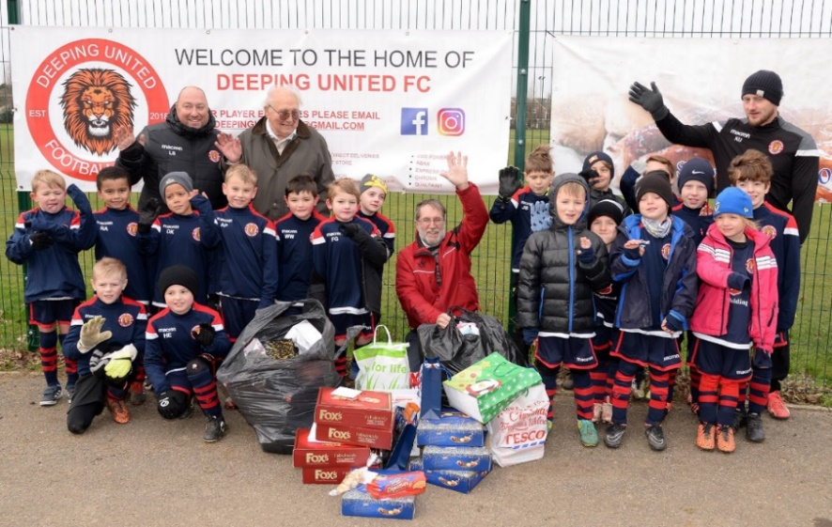
Here is a group of some of our youngest players within the club.... at Christmas time Deeping United decided to give something back to the community, so committee members, players and parents of each age group rallied together to collect boxes of biscuits and Christmas cards to give to Age Concern for the senior members of the community as a gift at Christmas time! Another gesture from Deeping United FC

How can you help us?
As you may imagine operating a club of the size of Deeping United FC (23 teams as at August 2020) does require significant funding for equipment, pitch rentals, entry fees into league and cup competitions and of course football kits for all age groups. We do charge a small fee each year to join the club but keep this a low as possible to ensure we open the club to as many people as possible.
We would like you to join us and help support the club but also work together to promote both the club and your business.
We have a number of sponsorship packages available but we would be delighted to discuss a more bespoke package to better fulfil your requirements.
The structure of the home and away kit sponsorship package is in four bands due to the number of players in each team. Each age group does tend to have more than one team which are coloured red, white and blue i.e. ‘Under 10 Red’ and a number of age groups also have boys/men, mixed and girls/ladies’ teams. Each kit is used for a total of two years.

BAND A | BAND B | BAND C | BAND D
Under 5  Under 6  Under 7  Under 8 | Under 9  Under 10  Under 11  Under 12 | Under 13  Under 14  Under 15  Under 16 | Under 18  Mens reserves  Mens first  Ladies first  Mens veterans  Ladies veterans  Walking football  Special Needs football
£300 per kit | £400 per kit | £500 per kit | £600 per kit

Home Kit
The home kit consists of a navy/red football shirt, navy blue shorts and navy blue/ red socks. The sponsors name is printed across the front of every shirt.
These kits will be worn at every home game in league matches, cup matches, friendly matches, and tournaments

Away Kit
The away kit consists of a pink football shirt, grey shorts and grey socks. The sponsors name will be printed across the front of every shirt.
These kits will be worn for every away game in league matches, cup matches, friendly matches and tournaments
In addition to team kit sponsorship we also offer an opportunity to support the club in general to assist with day to day operational costs and to provide equipment. We also hold a number of events over each season, such as our end of season presentation event which would again provide an ideal opportunity to maximise the exposure of your organisation through sponsorship of the individual events.

How can we help you?
In addition to the exposure your organisation will receive as a result of kit sponsorship, given the kit will be worn for every league match, cup match, friendly match and tournament, we would also advertise your organisation on our website both in our sponsor list on our home page and also in the sponsor list in the footer of every page. This would include your corporate logo and also a brief description of your organisation. We would also look to promote your organisation across our social media platforms as described above.

Our website contains a number of individual player profiles which we would look to expand and include sponsor profiles again highlighting your business, the services you provide but also why you chose to partner with Deeping United FC.

We would also like to invite you down to training sessions and matches for photo opportunities and to be able to present medals and trophies to the players, which we would look to repeat at the end of season presentation event which provides an opportunity for you to sponsor the event, part of the event, but to be able to present end of season awards to all the players in your selected team.

At the end of every season, both a home and away shirt from every age group will be signed by all the players of that team, framed, and then auctioned off at our club end of season presentation evenings, providing parents/grandparents the opportunity to have a keepsake of that season. Each shirt will have your corporate logo emblazoned on the front thus acting a reminder of your generous sponsorship for many years to come.

Let’s Talk
Should you require any further information about our club or wish to discuss further opportunities for us to work in partnership then please contact us as commercial@deepingunitedfc.com

