Deeping United Football Club

Guide to Using Full-Time

Prior to the season commencing you will receive an email to log in and verify your online credentials to the Full-Time website. If you do not receive this email (check spam folders), please inform the Secretary so they can arrange to have it re-issued to you.
During the season coaches for each team are required to complete a couple of tasks after any games played;
- Required within 30mins of the game finishing - Reply to the Full-Time fixture text which you will receive during your game with the result score in the format necessary e.g. H-A DUFC8R or 2-0 DUFC8Red, this being the Home team score followed by Away team score and your teams Full-Time code (displayed on the text you receive).

Where your game is postponed reply P-P with the team code. Abandonment should be replied with A-A and the team code.

- Required within 48 hours of your game finishing - Complete the online game details including;
  - Result
  - Referee marks (out of 100) – A mark below 65 requires a formal written report to the league office within 72 hours of the fixture
  - Respect marks
  - Pitch quality marks
  - Team information (starting, bench, goals and bookings / sending offs)
The below reflects screen shots of the online screens you should follow to be able to complete the online game information;
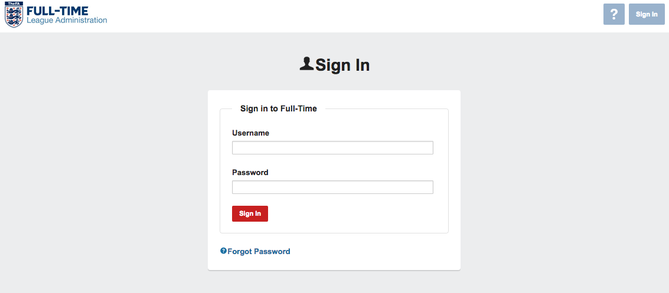
Log in and you will see this screen
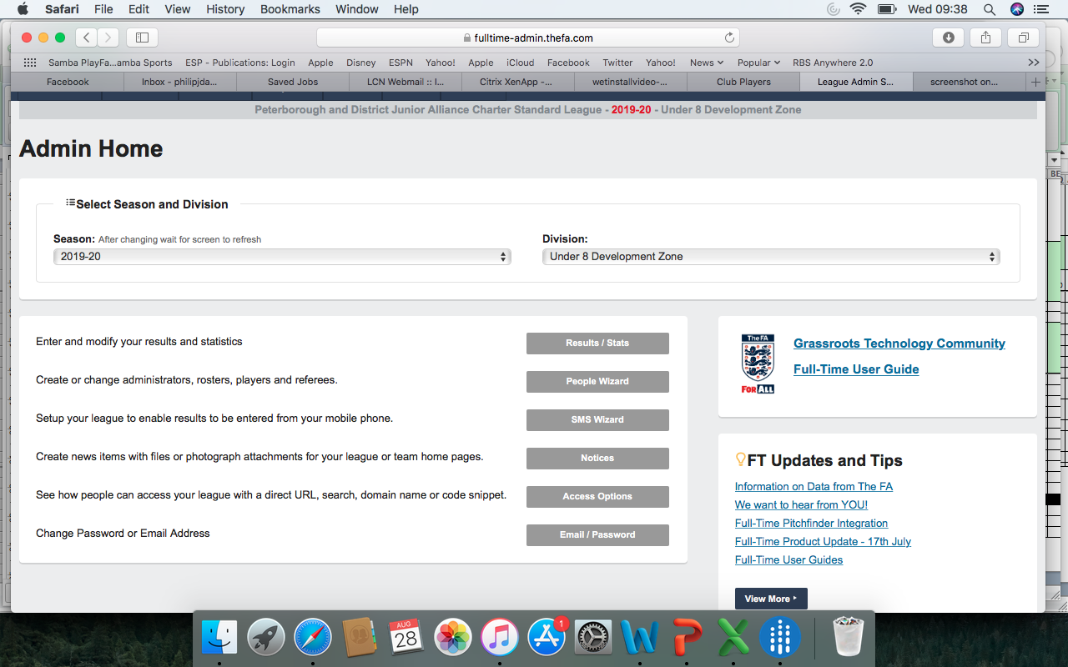

Select the “Results / Stats” option, the below screen while appear with your last fixture;
The scores should already be populated from your SMS text but if incorrect over-ride these and resubmit by clicking the update button (top left of the page).
You do not need to add anything in the “Notes” section unless particular relevance such as feedback for referee.
Now select the “Enter Statistics” command button
The below screen will appear
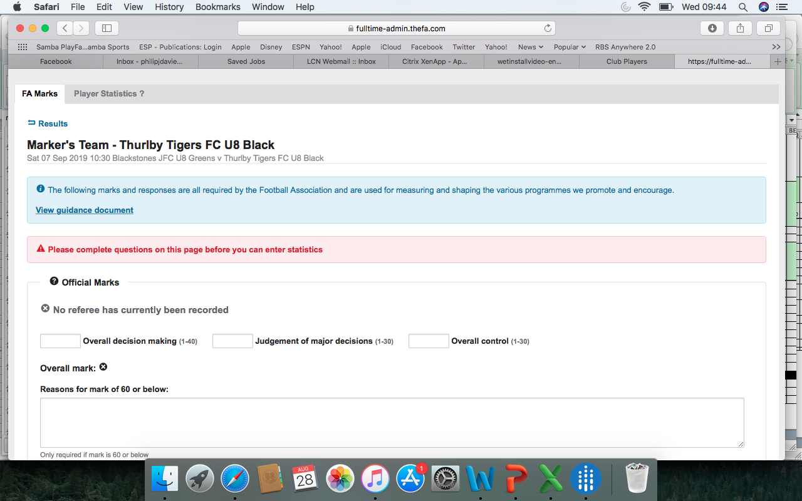
Complete the referee marks as shown on the page, note a overall score below 60 for the referee will require a separate letter completed within 24hrs and submitted to the secretary of the club.
Complete the “Respect Questions” and “Pitch Quality Scoring” scoring 1-5 for the relevant responses (1 being Very Poor and 5 being Excellent).
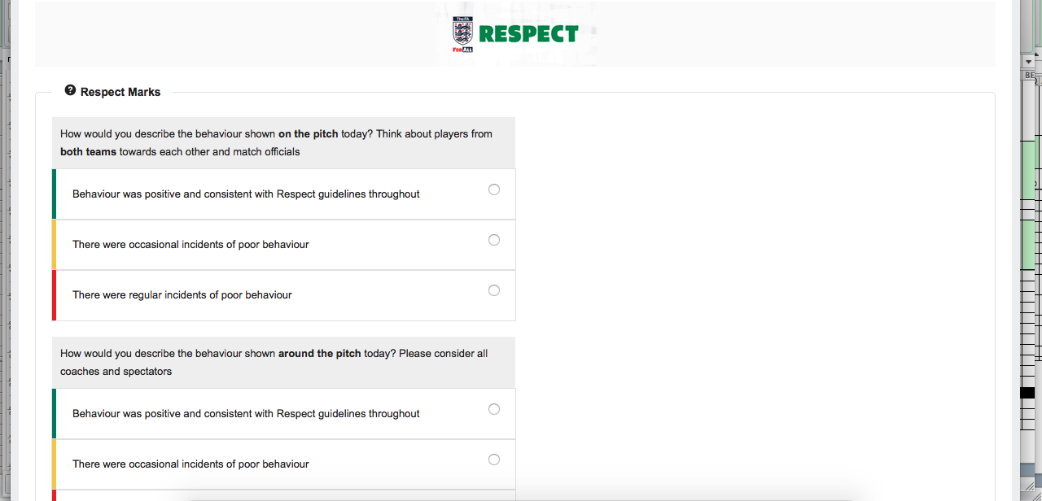
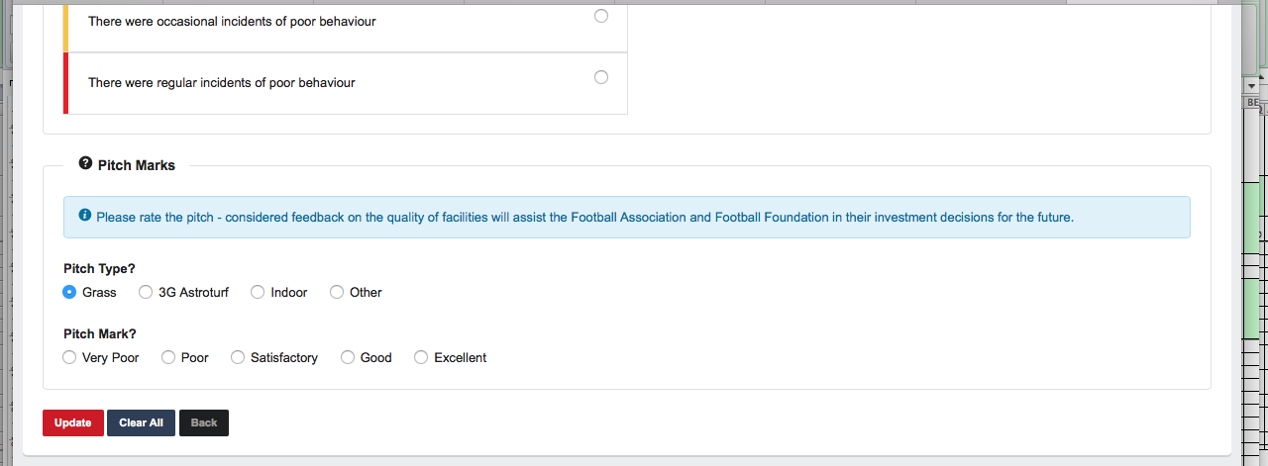
Again now click the “Update” command button this will save the data.
Now select “Player Statistics” at the top of the page (next to FA Marks)
The following screen will appear (if not select the “Quick Stat Entry” option)
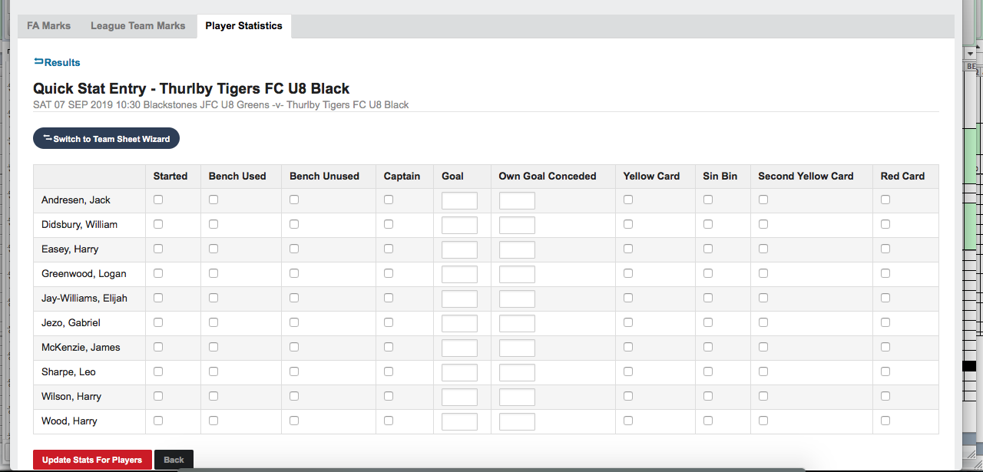
Now simply enter the information for your game.
Once complete click the “Update Stats for Players” command button at the bottom of the page.
Now click the “League Team Marks” tab – This will not always appear and depends on the marks provided for the referee. Complete the information on this tab in the briefest of formats as you will still need to supply any further information to the secretary;
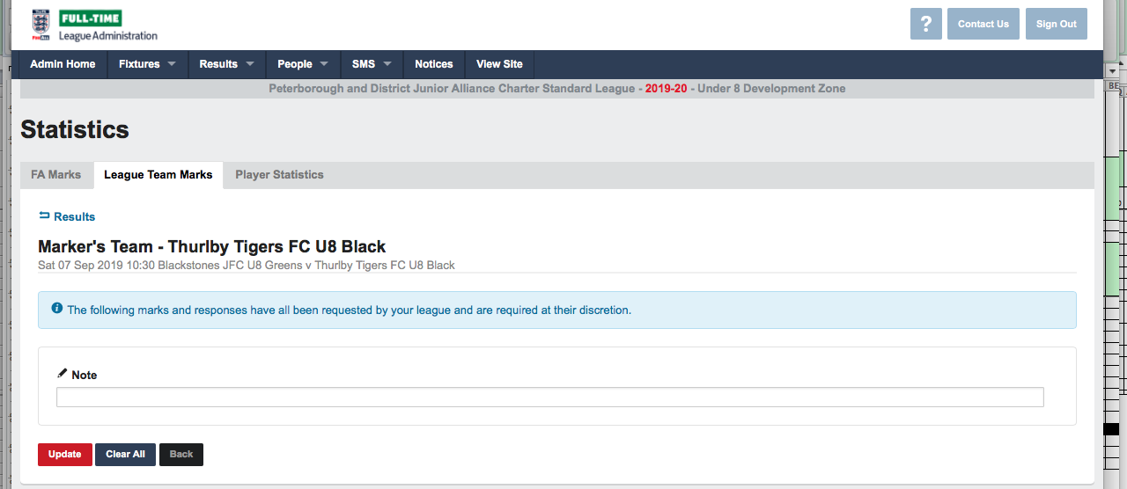
Click the update button once again and then return to the results page (fist page you came to).
Check all the data appears on the summary information and click update for the final time.
All is now saved and complete, you can log off.

Reviewed By | Reviewed Date | Sign Off | Comments
Emma Pearce | 28/08/2019 | Emma Pearce

