Video link provides instruction on CPR and how to use an AED;

http://www.sja.org.uk/sja/first-aid-advice/first-aid-techniques/using-a--defibrillator-aed.aspx

How do I use a defibrillator/AED;
You can use an AED with no training. The machine analyses someone’s heart rhythm and then uses visual or voice prompts to guide you through each step.
- First, make sure someone has called for an ambulance, and, if an AED isn’t immediately available, give CPR (cardiopulmonary resuscitation) until someone can bring you an AED.

- As soon as you’ve got an AED, switch it on. It will immediately start to give you a series of visual and verbal prompts informing you of what you need to do. Follow these prompts until the ambulance arrives or someone with more experience than you takes over.

- Take the pads out of the sealed pack. Remove or cut through any clothing and wipe away any sweat from the chest

- Remove the backing paper and attach the pads to their chest

- Place the first pad on their upper right side, just below their collarbone as shown on the pad

- Then place the second pad on their left side, just below the armpit. Make sure you position the pad lengthways, with the long side in line with the length of the their body

- Once you’ve done this, the AED will start checking the heart rhythm. Make sure that no-one is touching the person. Continue to follow the voice and/or visual prompts that the machine gives you until help arrives.

Adults - AED positions - Child - AED positions - Baby - AED positions
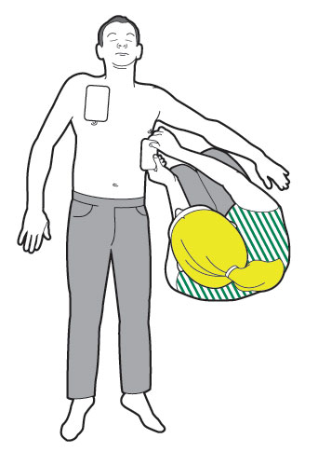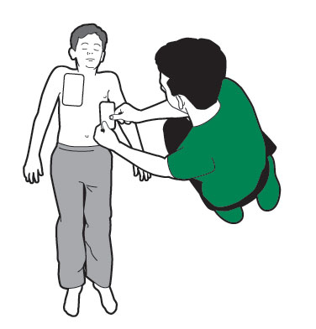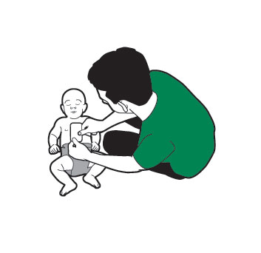
Reviewed By | Review Date | Sign Off | Comments

